First-Come, First-Served (FCFS)
# Source: AI Source: Provided by: [Data Path: Persons Table -> ID Column: 1, Name_En Column: Motasem Essam] -> From: [ChatGPT] on [1/21/2026]
First-Come, First-Served (FCFS) is one of the simplest scheduling algorithms used in both general and real-time systems, though it is less suitable for hard real-time systems because it does not consider task deadlines.

Definition
# Source: AI Source: Provided by: [Data Path: Persons Table -> ID Column: 1, Name_En Column: Motasem Essam] -> From: [ChatGPT] on [1/21/2026]
FCFS is a non-preemptive scheduling algorithm in which tasks are executed in the order they arrive in the ready queue.
- The first task to arrive is the first to execute, and the next task waits until the current task finishes.
- Priorities and deadlines are ignored.

Key Features
# Source: AI Source: Provided by: [Data Path: Persons Table -> ID Column: 1, Name_En Column: Motasem Essam] -> From: [ChatGPT] on [1/21/2026]
- Non-Preemptive: Once a task starts, it cannot be interrupted until it finishes.
- Simple to Implement: Uses a FIFO (First-In, First-Out) queue.
- Fair: Every task eventually gets executed in the order it arrived.

Advantages
# Source: AI Source: Provided by: [Data Path: Persons Table -> ID Column: 1, Name_En Column: Motasem Essam] -> From: [ChatGPT] on [1/21/2026]
- Easy to implement – requires minimal logic.
- Fair for all tasks – no starvation, as tasks execute in arrival order.
- Deterministic for small systems – simple queue ensures predictable execution order.

Disadvantages
# Source: AI Source: Provided by: [Data Path: Persons Table -> ID Column: 1, Name_En Column: Motasem Essam] -> From: [ChatGPT] on [1/21/2026]
- Not suitable for real-time tasks – tasks with urgent deadlines may miss them.
- Poor average waiting time if a long task arrives first (convoy effect).
- No priority support – cannot handle critical tasks differently.

Example
# Source: AI Source: Provided by: [Data Path: Persons Table -> ID Column: 1, Name_En Column: Motasem Essam] -> From: [ChatGPT] on [1/21/2026]
Suppose three tasks arrive at a real-time system:
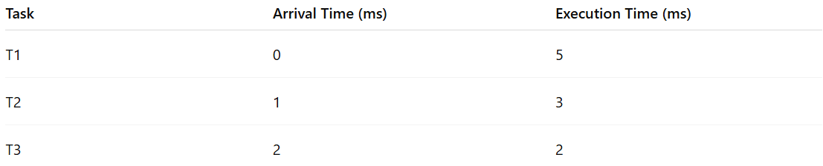
Task | Arrival Time (ms) | Execution Time (ms)
T1 | 0 | 5
T2 | 1 | 3
T3 | 2 | 2
FCFS Execution Order: T1 → T2 → T3
- Task T2 and T3 must wait until T1 finishes, even if their deadlines are sooner.
- If T2 had a very tight deadline, it might miss it, showing why FCFS is unsuitable for hard real-time systems.

Why FCFS Matters for Software Engineers
# Source: AI Source: Provided by: [Data Path: Persons Table -> ID Column: 1, Name_En Column: Motasem Essam] -> From: [ChatGPT] on [1/21/2026]
- Useful for understanding basic scheduling principles.
- Suitable for non-critical or batch-processing systems.
- Provides a baseline for comparing more advanced scheduling algorithms like RMS, EDF, or LLF.

